Chapter 3

System Analysis

3.1 Introduction
3.1.1 Purpose
The purpose of this chapter is to lay down the broad user requirements for the “vCamView” Application. This document is for users and the project development team.
System Requirement Specification (SRS) for “vCamView” mobile application has been prepared with a view to provide the following:

- Details of the user requirements that needs to be supported by the application
software.
- A basis for mutual understanding between the users and software design/
customization/development team.
- A basis for subsequent system development and testing

This document presents the functional details of the constituent modules of the “vCamView” for the Authority/Client

3.1.2 Scope
This document gives the framework of the following:
- Functional overview of the vCamView application.
- Broad functionalities within vCamView application.
- External and internal interfaces of the modules of vCamView.

3.1.3 How to Use this Document
All users of this document should carefully read it, and ensure the following:
- All requirements have been listed and detailed
- Functionality described in this document is clear and unambiguous.

3.1.4 List Of Abbreviations
Table 3.1: List Of Abbreviation
Abbreviation/ Acronym | Description
AR | Augmented Reality
API | Application Program Interface
SDK | Software Development Kit
2D | 2 Dimensional space
3D | 3 Dimensional space
COS | Co-Ordinate Systems
FPS | Frame per second
iOS | An operating system developed by Apple Inc. for mobile devices such as iPhone and iPad
FAQ | Frequently asked questions

3.2 Requirement Specification

3.2.1 Functional Requirements
R1 Object Configuration
Processing: The Objects(it may be 2D or 3D) are tracked and their configuration is stored in one configuration file. Then Details of particular object with corresponding URL, Audio, Video etc. are taken as user input and stored in Database for future detection of that object.
R1.1 Tracking Object

R1.1.1 Tracking 2D object
Input: Pressing Capture Button
Processing: Capture the Image and generate corresponding configuration file
Output: Generated configuration file in temporary storage

R1.1.2 Tracking 3D object
Input: Pressing Start Tracking Button and User moves the iPhones's camera over the scene very gently
Processing: Application will generate corresponding 3dmap and configuration file
Output: Generated configuration file and 3dmap in temporary storage

R1.2 Add details of object
Input: User enters the object name, object description, reference URL
Processing: Saving object name, object description, reference URL in temporary strings
Output: Object details in temporary Strings

R1.3 Add Media

R1.3.1 Add Audio
Input: User clicks the Add Audio button
Processing: It opens up list with option “Record Audio” and “Audio From Library”

R1.3.1.1 Record Audio
Input: User Clicks “Record Audio”→Record
Processing: It starts recording, when user presses pause button, it pauses recording, when user presses stop button, it stops recording, if user presses play button then it plays the recorded audio, when user presses the save button, it saves the audio in temporary directory
Output: Saved Audio in temporary directory

R1.3.1.2 Use Audio From Library
Input: User Clicks “Audio From Library”
Processing: It opens up the list of audio files present in media library, user selects necessary file and presses done button, it saves path for audio file in string
Output: Saves audio file path of selected audio file

R1.3.2 Add Video
Input: User clicks the Add Video button
Processing: It opens up list with option “Record video” and “Video From Library”

R1.3.2.1 Record Video
Input: User Clicks “Record Video”→Record
Processing: It starts recording, when user presses pause button, it pauses recording, when user presses stop button, it stops recording, if user presses “Retake” then it takes video recording again, when user presses the “Use it” button, it saves the video in temporary directory
Output: Saved video in temporary directory

R1.3.2.2 Use Video From Library
Input: User Clicks “Video From Library”
Processing: It opens up the list of video files present in media library, user selects necessary file and presses done button, it saves path for video file in string
Output: Saves video file path of selected video file

R1.4 Save details
Input: User presses the save button
Processing:
- Take the details of object from temporary Strings and save the details in database
- Move the audio, video and 3dmap(if 3D) files from temporary directory to document directory(permanent storage) of application
- Merge the configuration file from temporary directory with main configuration file stored in document directory
Output: Fully configured Object with corresponding details stored in permanent storage

R2 Detection

R2.1 Detecting 2D object
R2.1.1 Image Comparison
Input: User presses 2D detection button
Processing:
- Start camera screen
- Fetching each encrypted images and its configuration from main configuration file(from documents directory)
- Comparing each frame from camera(with 30 FPS speed) with each images from configuration file.
- If any frame matches 70% with any image from configuration file then finding out its CoordinateSystemID
Output: CoordinateSystemID of the object in camera matched with image from configuration file
R2.1.2 Display Information
Input: CoordinateSystemID
Processing: By using CoordinateSystemID, find out the corresponding object details from database
Output: Overlay over camera screen with object name, its description and Play audio and video buttons

R2.1.3 Play Media
R2.1.3.1 Play Audio
Input: User presses Play Audio button
Processing: Popping up the audio controls view having play, pause, forward, rewind etc. buttons and slider showing audio progress
Output: Corresponding audio sound
R2.1.3.2 Play Video
Input: User presses Play Video button
Processing: Showing Video Player view having play, pause, forward, rewind etc. buttons, slider showing video progress, slider for adjusting sound
Output: Corresponding Video Display

R2.2 Detecting 3D Object
R2.2.1 Compare 3dmap
Input: User presses 3D detection button
Processing:
- Start camera screen
- Fetching each 3dmaps from .f3b files and its configuration from main configuration file(from documents directory)
- Comparing each frame from camera(with 30 FPS speed) with each 3dmap from configuration file
- If any frame matches 70% with any view of 3dmap from configuration file then finding out its CoordinateSystemID
Output: CoordinateSystemID of the object in camera matched with image from configuration file

R2.2.2 Display Information
Input: CoordinateSystemID
Processing: By using CoordinateSystemID, find out the corresponding object details from database
Output: Overlay over camera screen with object name, its description and Play audio and video buttons

R2.2.3 Play Media
R2.2.3.1 Play Audio
Input: User presses Play Audio button
Processing: Popping up the audio controls view having play, pause, forward, rewind etc. buttons and slider showing audio progress
Output: Corresponding audio sound
R2.2.3.2 Play Video
Input: User presses Play Video button
Processing: Showing Video Player view having play, pause, forward, rewind etc. buttons, slider showing video progress, slider for adjusting sound
Output: Corresponding Video sound

R3 Edit Preconfigured Object
R3.1 Object Selection
Input: User selects the “edit object details” and selects the object needed to be edit
Processing: It shows up the list of all 2D and 3D objects, now user have to select the object which he wants to edit, after selecting the object, new window –just like add detail will open up, the older details are there in each textbox
Output: The window for editing the filled information will be shown up

R3.2 Edit details of object
Input: User will edit the object description and reference URL
Processing: Saving the object description, reference URL in temporary strings
Output: Object details in temporary Strings

R3.3 Edit Media

R3.3.1 Edit Audio
R3.3.1.1 Play Available Audio
Input: User presses “Edit Audio” → “Play Available Audio”
Processing: It will pops up the controls for managing the audio, and starts playing the available audio
Output: Audio Sound
R3.3.1.2 Remove Available Audio
Input: User presses “Edit Audio” → “Remove Available Audio”
Processing: This will remove the audio file stored in permanent document directory and stores null in audio file path
Output: Deleted video from permanent directory and storing null in audio file path
R3.3.1.3 Edit Audio
This will remove the original audio and add the new audio by using following ways
Input: User clicks the Edit Audio button
Processing: It opens up list with option “Record Audio” and “Audio From Library”

R3.3.1.3.1 Record Audio
Input: User Clicks “Record Audio”→Record
Processing: It starts recording, when user presses pause button, it pauses recording, when user presses stop button, it stops recording, if user presses play button then it plays the recorded audio, when user presses the save button, it saves the audio in temporary directory
Output: Saved Audio in temporary directory

R3.3.1.3.2 Use Audio From Library
Input: User Clicks “Audio From Library”
Processing: It opens up the list of audio files present in media library, user selects necessary file and presses done button, it saves path for audio file in string
Output: Saves audio file path of selected audio file
R3.3.2 Edit Video
R3.3.2.1 Play Available Video
Input: User presses “Edit Video” → “Play Available Video”
Processing: It will pops up the Window having video control buttons and starts playing the available video
Output: played Video display
R3.3.2.2 Remove Available Video
Input: User presses “Edit Video” → “Remove Available Video”
Processing: This will remove the video file stored in permanent document directory and stores null in video file path
Output: Deleted video from permanent directory and storing null in video file path
R3.3.2.3 Edit video
This will remove the original video and add the new video by using following ways
Input: User clicks the Edit Audio button
Processing: It opens up list with option “Record Video” and “Video From Library”

R3.3.2.3.1 Record Video
Input: User Clicks “Record Video”→ Record
Processing: It starts recording, when user presses pause button, it pauses recording, when user presses stop button, it stops recording, if user presses “Retake” then it takes video recording again, when user presses the “Use it” button, it saves the video in temporary directory
Output: Saved video in temporary directory
R3.3.2.3.2 Use Video From Library
Input: User Clicks “Video From Library”
Processing: It opens up the list of video files present in media library, user selects necessary file and presses done button, it saves path for video file in string
Output: Saves video file path of selected video file

R1.4 Save Edited details
Input: User presses the save button
Processing:
- Take the details of object from temporary Strings and save the details in database
- Move the audio, video and 3dmap(if 3D) files from temporary directory to document directory(permanent storage) of application
- Merge the configuration file from temporary directory with main configuration file stored in document directory
Output: Fully configured and Edited Object with corresponding details stored in permanent storage

R4 Change Settings
This will change the display settings of the overlay view information which was going to be displayed when object will get detected.
R4.1 Hide or Show the Information Settings
Input: This will shows up the controls button for each information that will be getting shown up at time of detection, user will on/off the switches available as per his need to show information
Processing: This will saves the changed settings in Boolean form in temporary strings
Output: Changed settings saved in temporary strings

R4.2 Save settings
Input: User presses the save button after changing the settings to save the changed settings permanently
Processing: This will saves the changed settings details in permanent property list files
Output: Saved settings

R5 Share information on Social Media
This will be used to share some message about this application on facebook or twitter.
Requirement: The facebook or twitter account details should already added and verified on that iPhone, if you want to change account details then go to settings of device and change the account details there
Input: User presses the “Share” button and then presses the “facebook” or “twitter”
Processing: This will opens up the window with some written message, if you want to change the message then change it and then press the share button to upload it as a status on your wall
Output: uploaded status about application on your social media wall

R6 Help
R6.1 Seeing solutions of Frequently asked questions (FAQs)
Input: User presses “FAQ” button
Processing: This will opens up new window having table. Each row of table contains many doubted questions about the application. When user touches any of the question, it will expand the table and shows up the solution for that question.
Output: Get solution for many FAQs

R6.2 Seeing snapshots with each button information
Input: User presses “Help” button
Processing: This will shows up the snapshots of each screen of mobile with information about each button, if want to see snapshot in fullscreen, then user just taps the photo, then navigation bar will hide and shows the snapshot in fullscreen.
Output: get information about each screen and each button of application.

3.2.2 Non Functional Requirements

R1 Usability
R1.1 Speed of Use
  - The Loading time of application should not be more than 15 seconds
  - The Camera with the configuration should open in less than 3 seconds.
  - The 2D Tracking time should not exceed 2 seconds
  - The 3D Tracking time should not exceed 2 minutes
  - The object information should be displayed in less than 2 seconds when user points camera to object
R1.2 Required User Ability
The user should know the basic handling of iOS devices

R2 Reliability
R2.1 Error Handling
    - The application should not crash
    - The application should not have memory leak
    - If any error occurs during runtime, it should notify user about it
R2.2 Ease of Recovery
If any crashing or error occurs in application, it should restore the all information and configuration data about object

R3 Performance
R3.1 Response Time
The response to each event from application should be such that it should not make user to wait long for responding
R3.2 Resource Usage
The memory requirement of application should be as minimum as possible. Also, the memory occupied by application should not affect the performance of other applications on that mobile.

R4 Supportability
R4.1 Ease of Installation
The installation procedure of application should be made easy so any novice user can install the application to his mobile

3.3 Navigation Chart

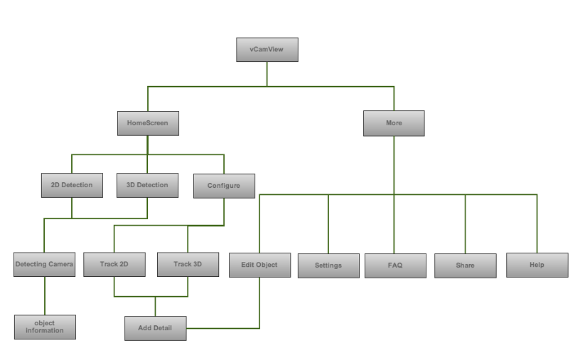

3.4 Use Case Diagram
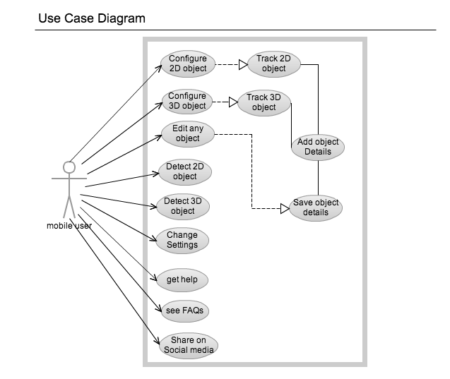
figure 1.1 : Use case diagram
3.5 Class Diagram

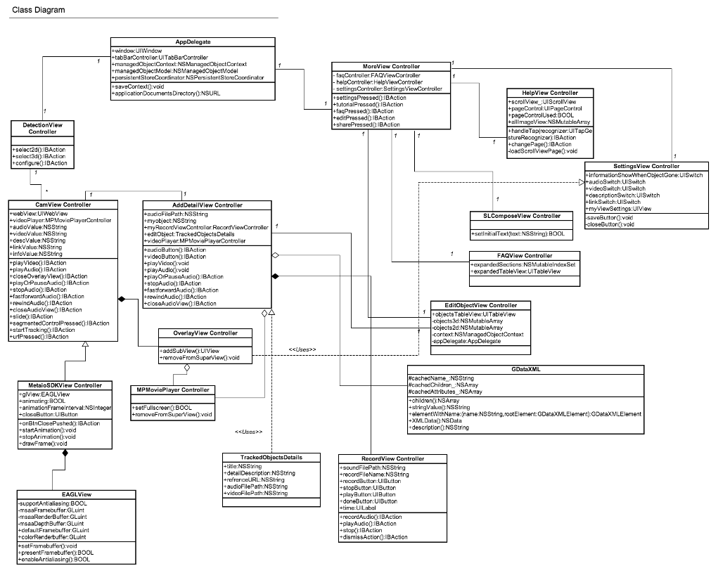
figure 1.1 : Class diagram

3.6 Sequence Diagrams
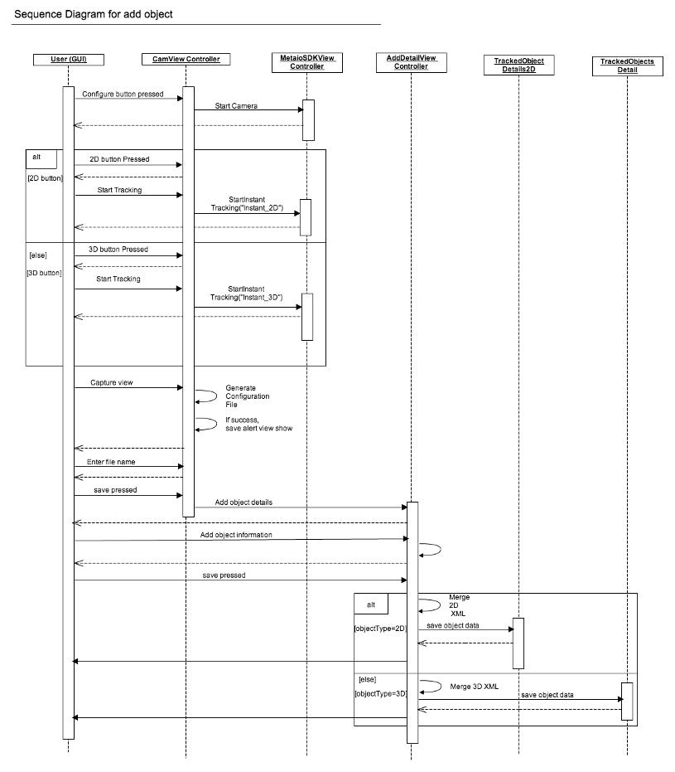
figure 1.1 : Sequence diagram for adding object
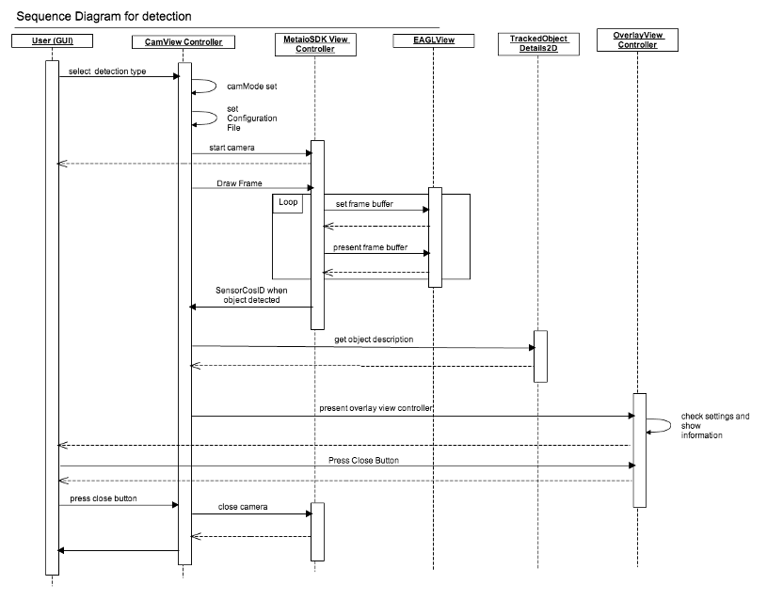
figure 1.1 : Sequence diagram for detection
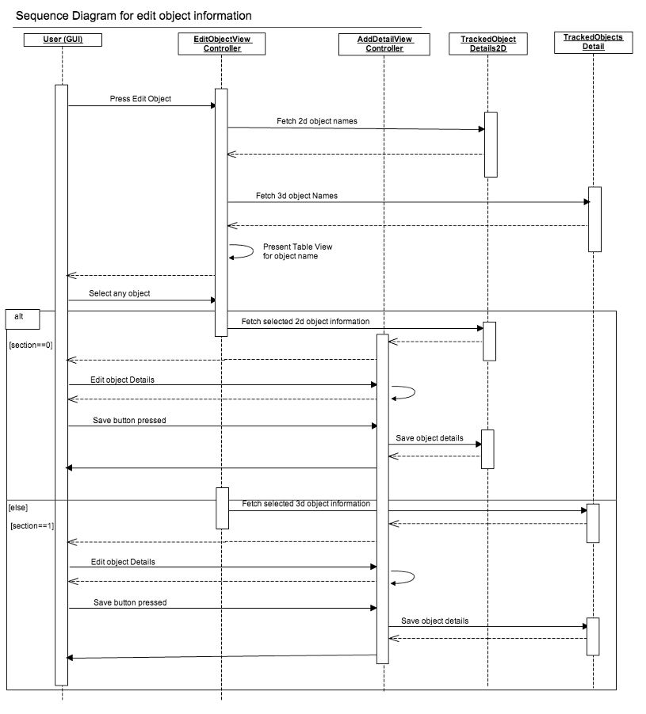
Figure 1.1 : sequence diagram for edit object information
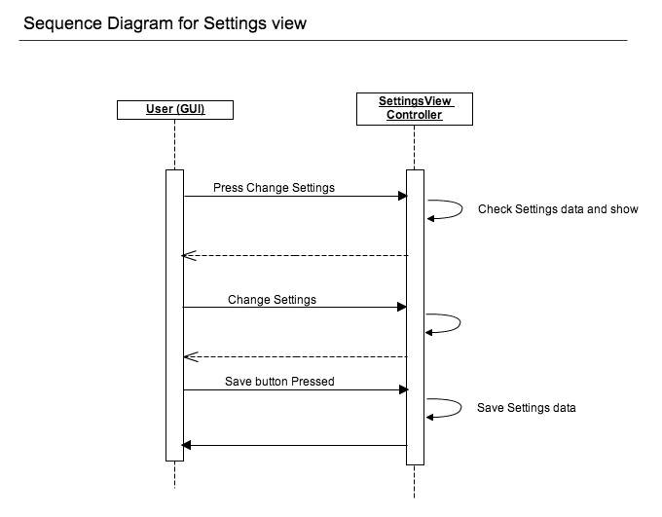
Figure 1.1 : sequence diagram for settings view

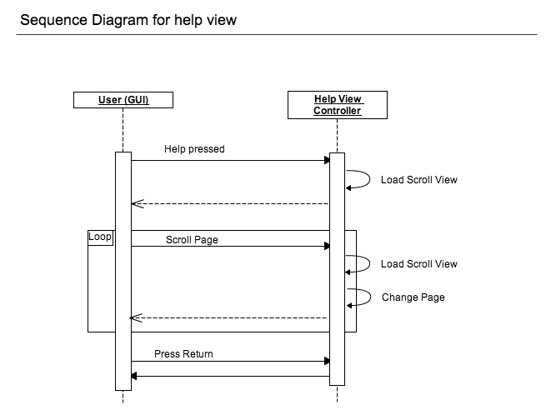
Figure 1.1 : sequence diagram for help view

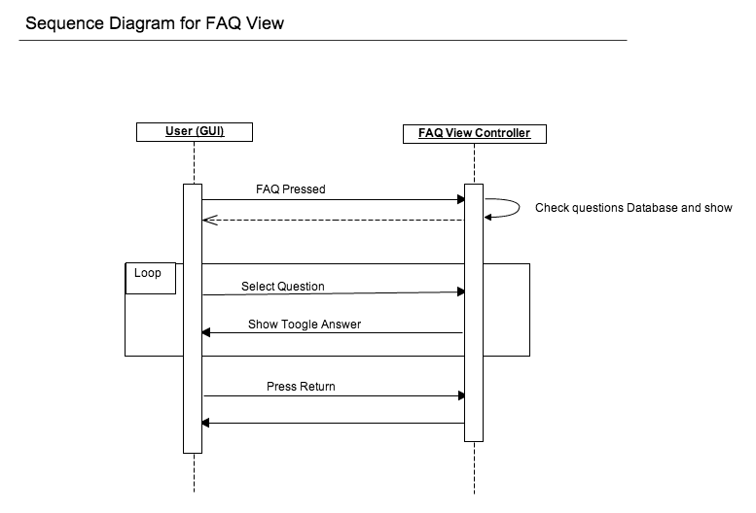

Figure 1.1 : sequence diagram for FAQ view

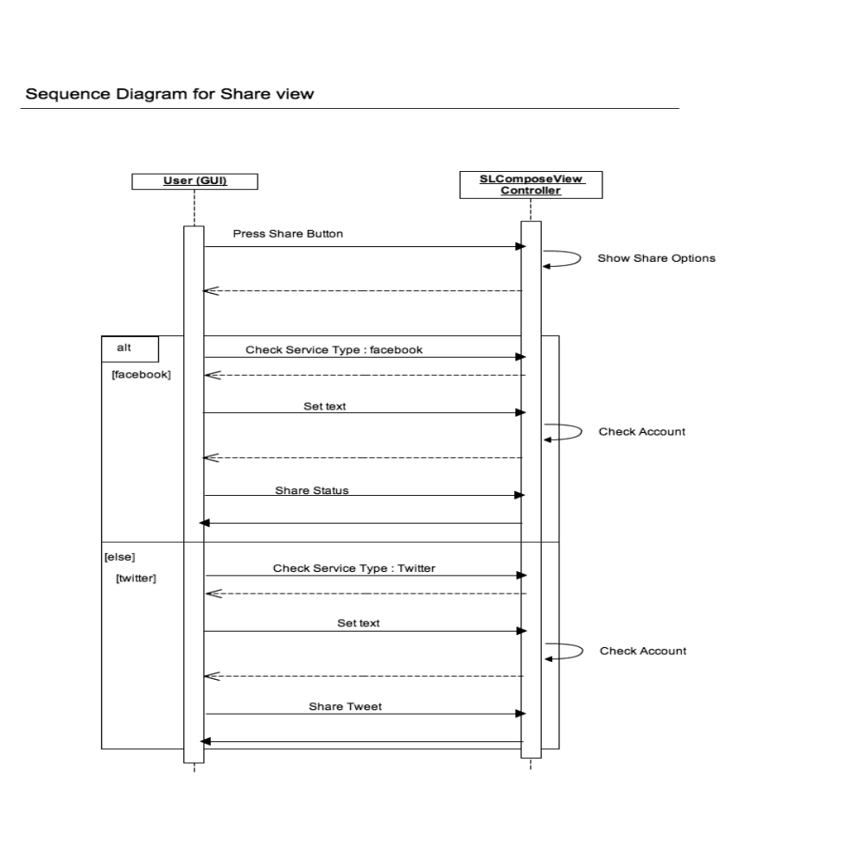
Figure 1.1 : Sequence diagram for share view

3.7 State Diagram
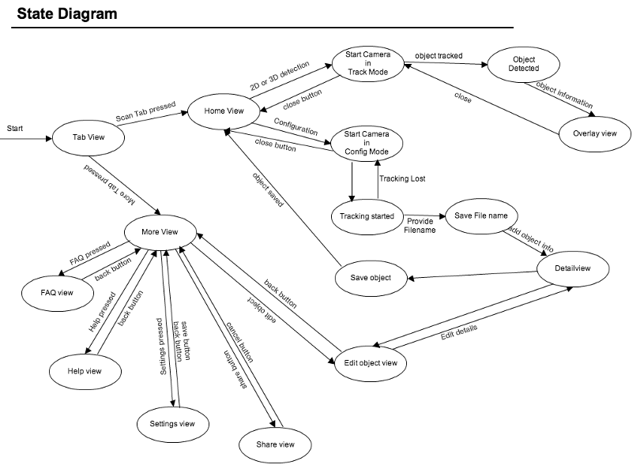
Figure 1.1 : state diagram

